Robot Model

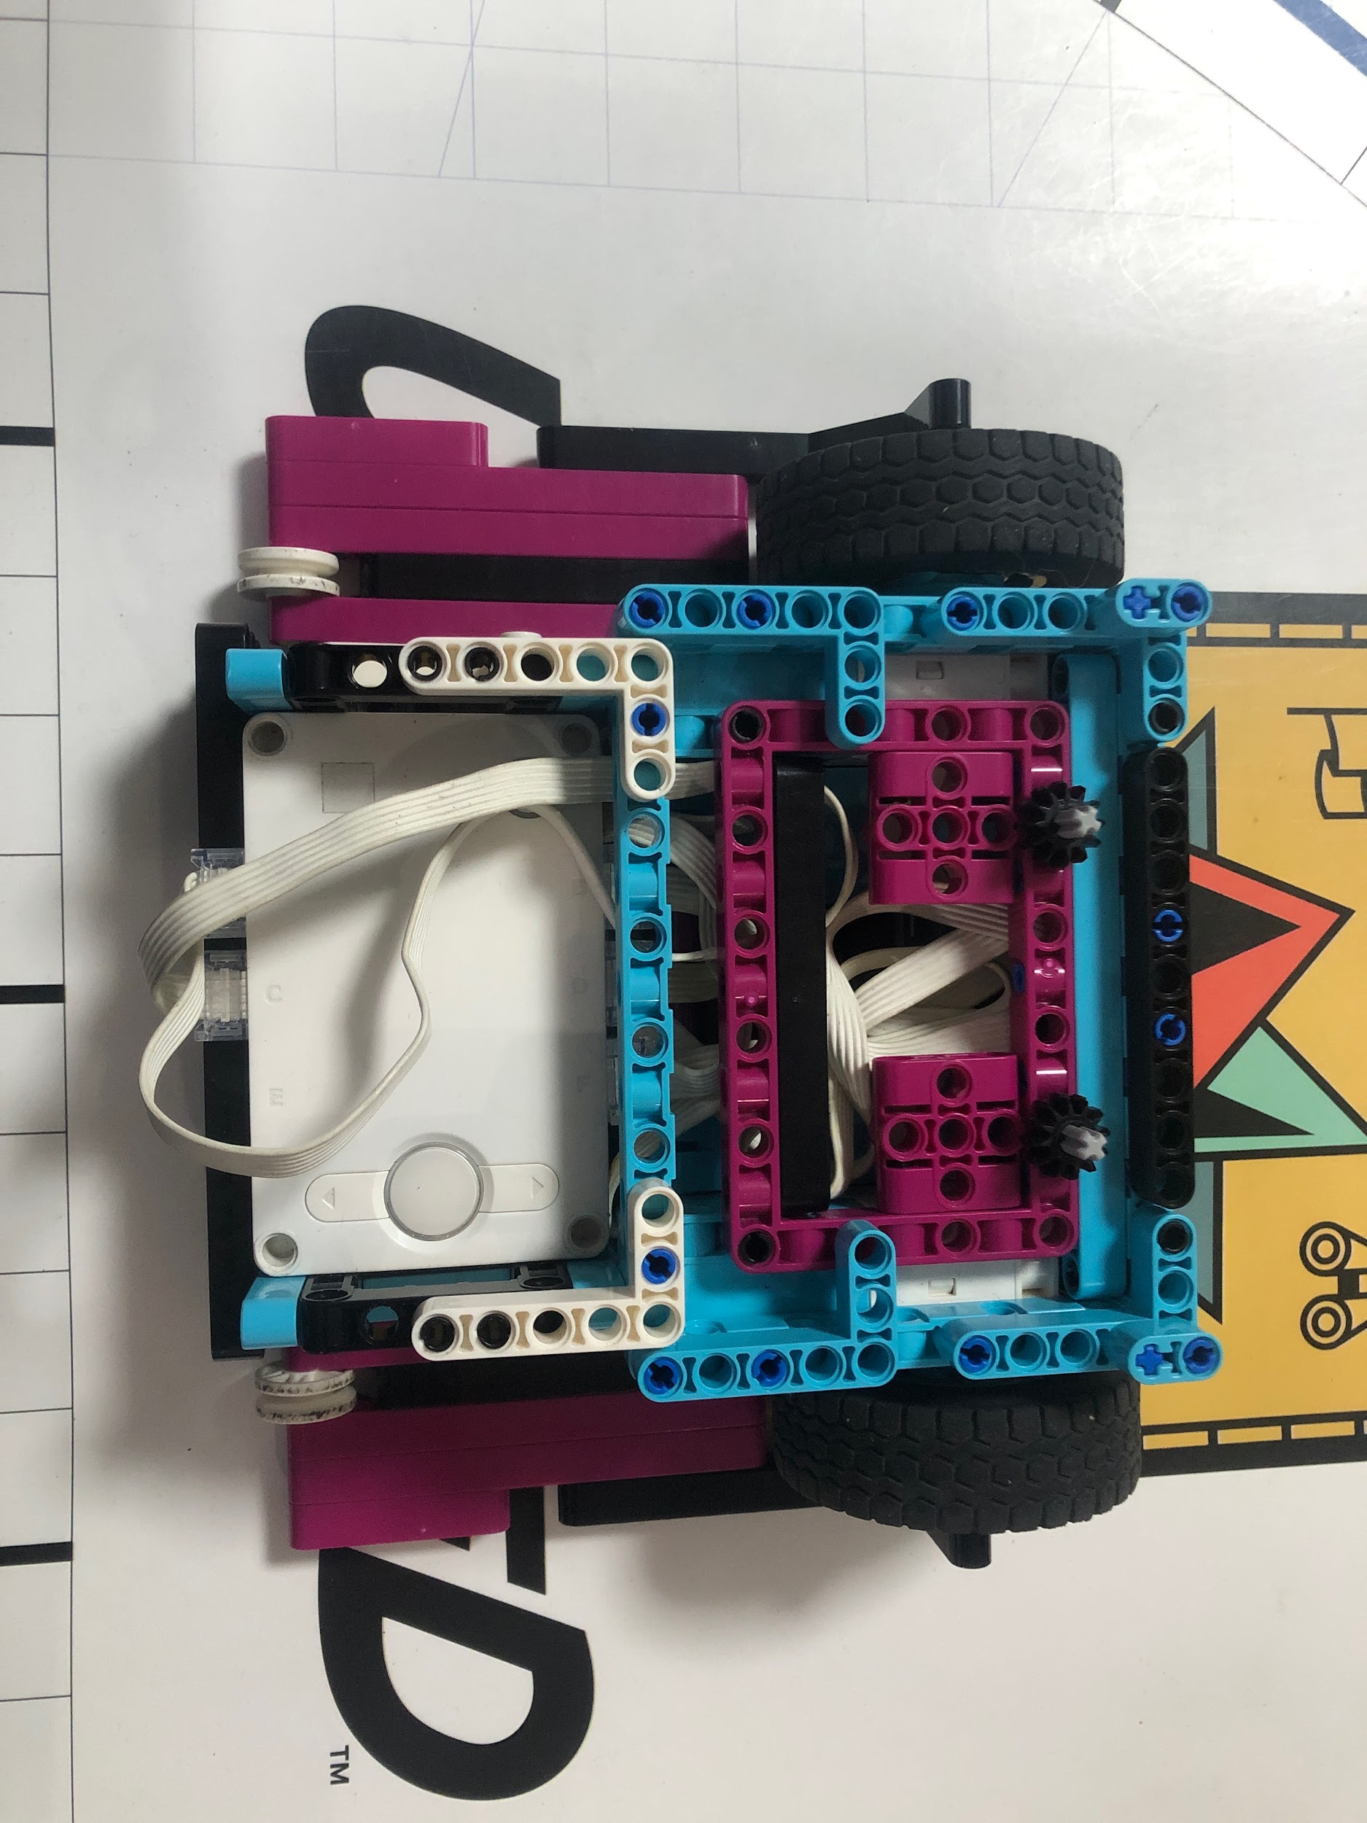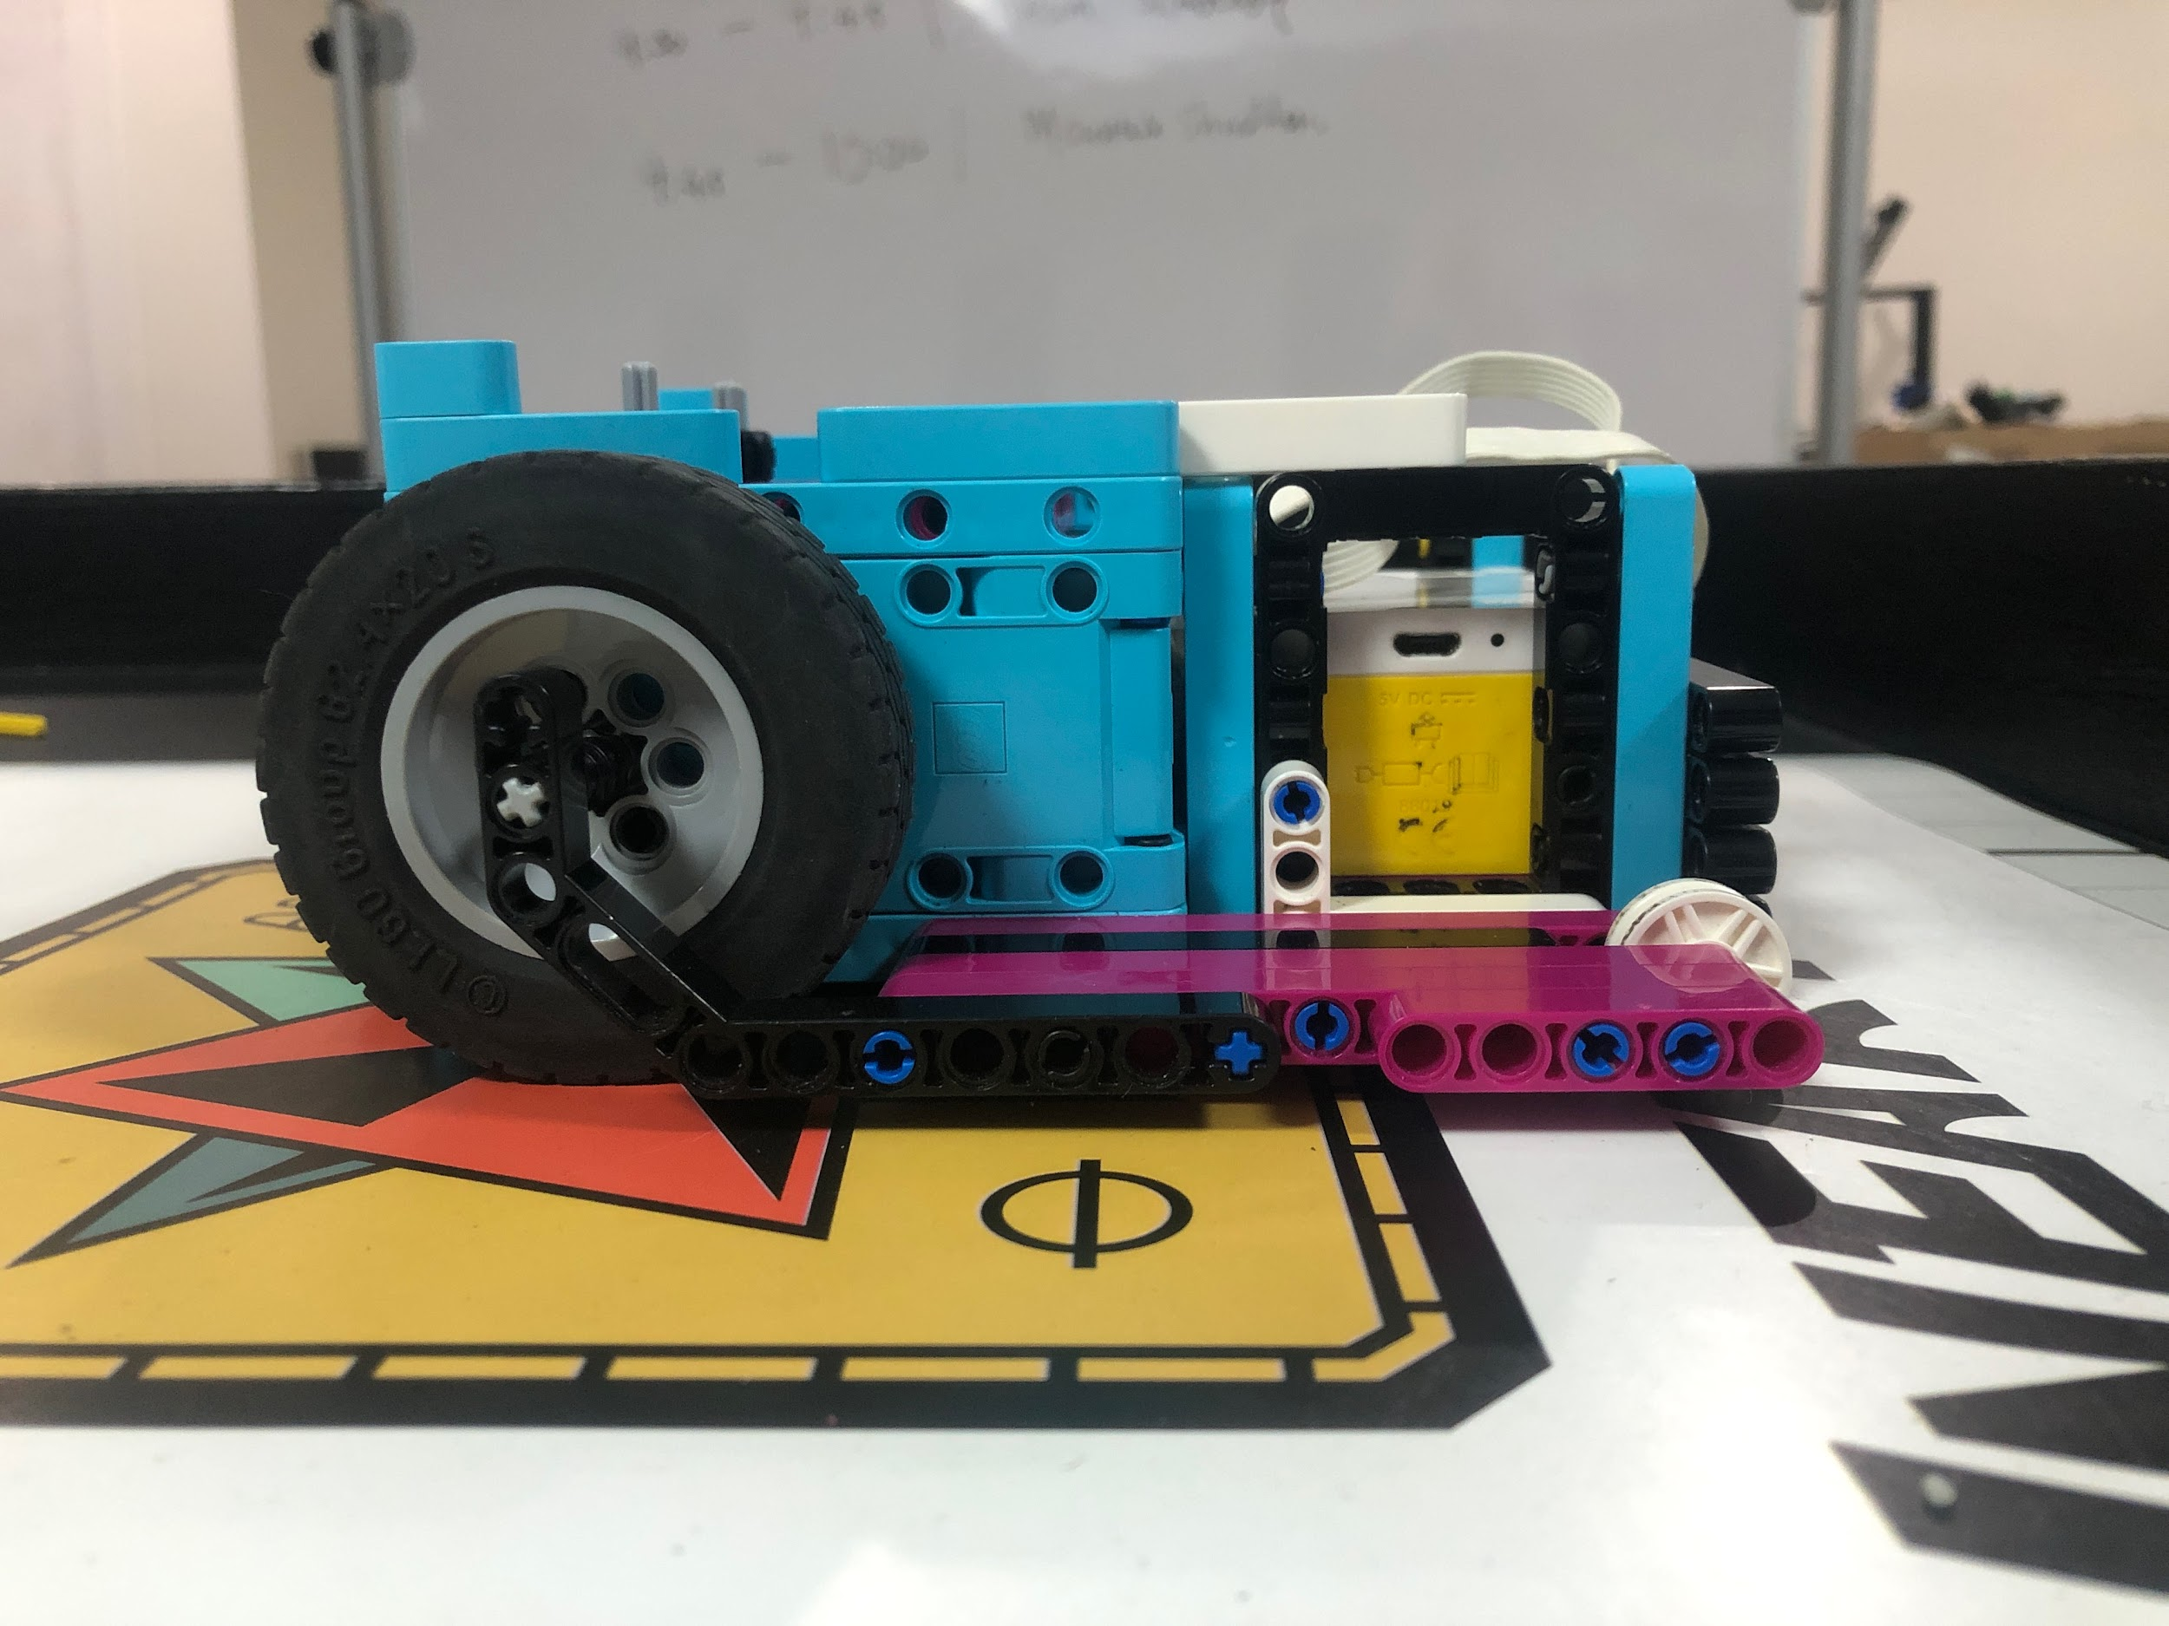

Mission 01/02/11 - Surface Brushing/Map reveal/Angler Artifacts

Attachment

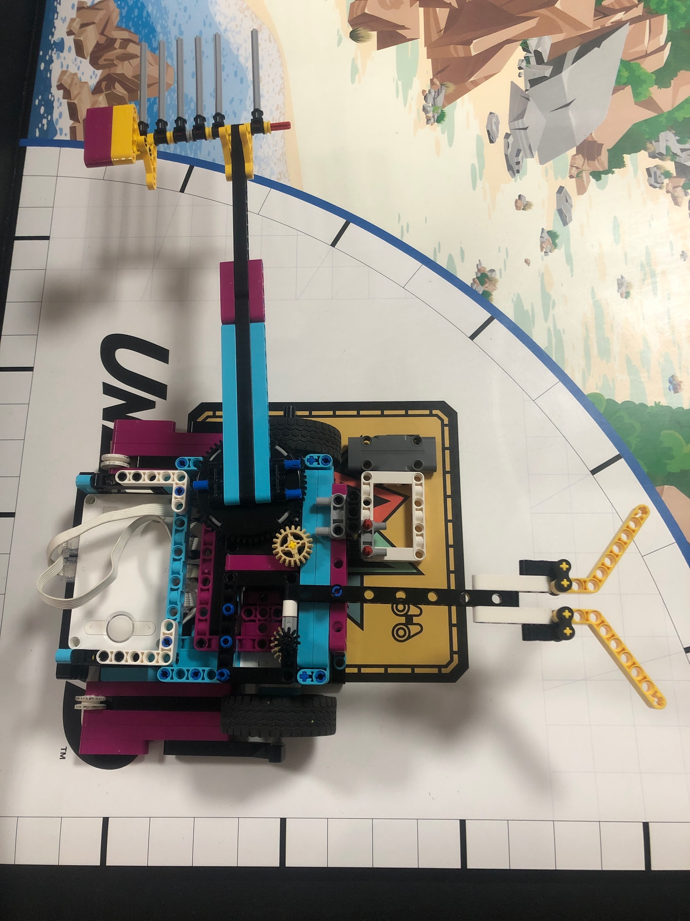

Code

Wireframe Diagram

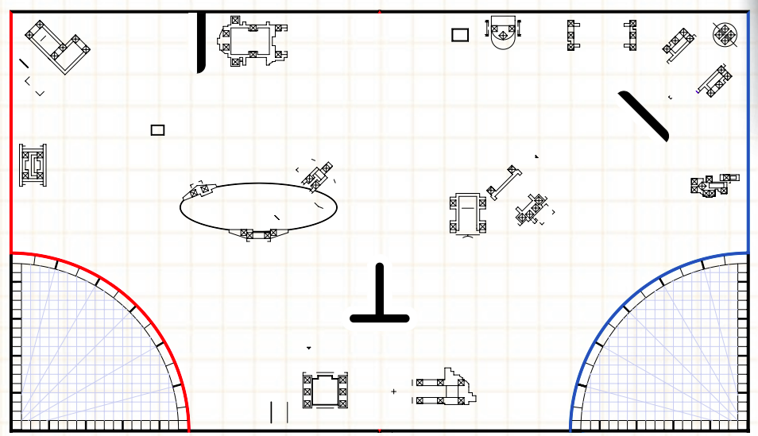

Silas

Mission 5/6/8 - who lived here / Forge / Silo

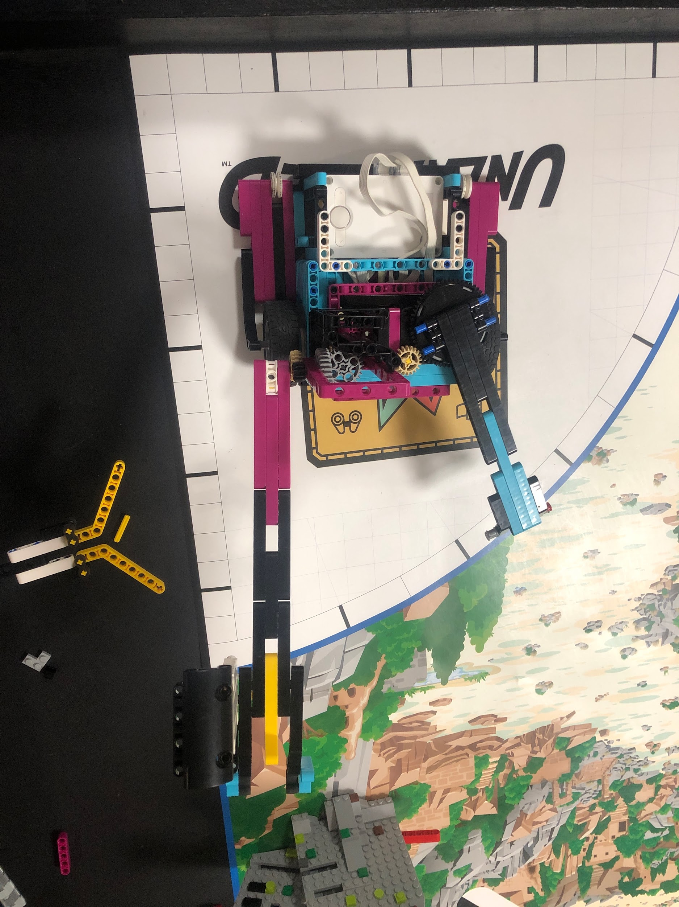

Code

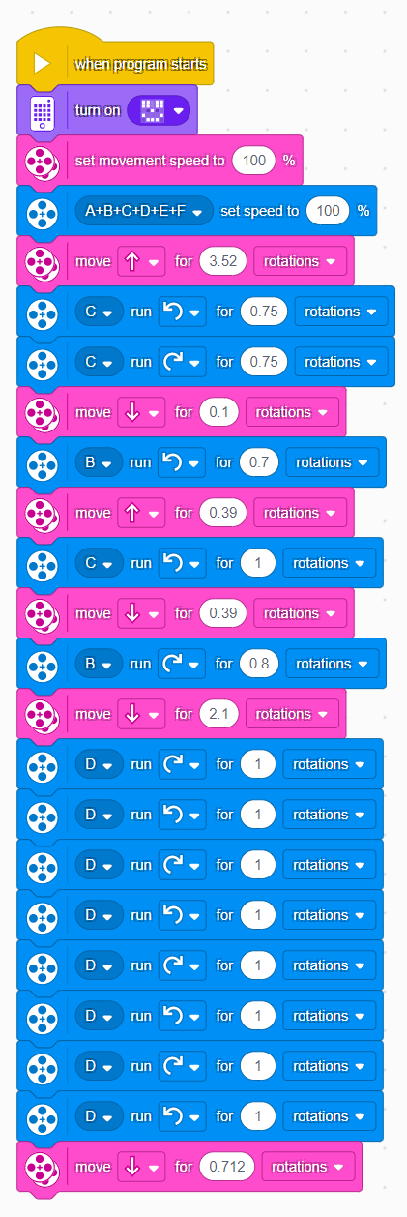

Mission 9/10

Attachment

Code

Wireframe Diagram

